

**SCHOOL OF COMPUTING AND INFORMATION TECHNOLOGY**

A PROJECT REPORT

ON

**“REAL TIME INFORMATION DISSEMINATION SYSTEM USING GPS ON VEHICLE ACCIDENT DETECTION”**

Submitted in partial fulfillment of the requirement for the award of the Degree of

**BACHELOR OF TECHNOLOGY**

**IN**

**COMPUTER SCIENCE AND ENGINEERING**

Submitted by

HARISH KUMAR M M (R14CS063)

Manikandan R (R14CS099)

Madem Vijay Kumar Reddy (R14CS091)

K Nirosh (R14CS073)

Under the guidance of

Prof. DR M PRABHAKAR

**May 2018**

Rukmini Knowledge park, Kattigenahalli, Yelahanka, Bengaluru-560064

[www.reva.edu.in](http://www.reva.edu.in)

**DECLARATION**

We, Harish Kumar M M, Manikandan R, Madem Vijay Kumar Reddy, K Nirosh students of Computer Science Engineering, belonging to **School of Computing and Information Technology**, REVA University, declare that this Project Report / Dissertation entitled “Real Time Information Dissemination System Using GPS On Vehicle Accident Detection” is the result of the project / dissertation work done by me under the supervision of Prof. Dr M Prabhakar, Associate Professor at School of Computing and Information Technology.

I am submitting this Project Report / Dissertation in partial fulfilment of the requirements for the award of the degree of Bachelor of Technology in Computer Science and Engineering by REVA University, Bengaluru during the academic year 2017-18.

I declare that this project report has been tested for plagiarism and has passed the plagiarism test with the similarity score less than 25% and it satisfies the academic requirements in respect of Project work prescribed for the said Degree.

I further declare that this project / dissertation report or any part of it has not been submitted for award of any other Degree/ Diploma of this University or any other University/ Institution.

*(Signature of the candidate)*

*Signed by me on*

*Certified that this project work submitted by Harish Kumar M M has been carried out under my / our guidance and the declaration made by the candidate is true to the best of my knowledge.*

*Signature of Guide*

*Date: ………..*

*Signature of Director of School*

*Date :………..*

*Official Seal of the School*



**SCHOOL OFCOMPUTING AND INFORMATION TECHNOLOGY**

# CERTIFICATE

Certified that the project work entitled **“Real Time Information Dissemination System Using GPS On Vehicle Accident Detection”** carried out under my / our guidance by **Harish Kumar M M** (**R14CS063), Manikandan R (R14CS099), K Nirosh (R14C073), Madem Vijay Kumar Reddy (R14CS091)**, bona-fide students of REVA University during the academic year 2017-18, is submitting the project report in partial fulfilment for the award of **Bachelor of Technology** in **Computer Science and Engineering** during the academic year **2017–18**. The project report has been tested for plagiarism and has passed the plagiarism test with the similarity score less than 25%. The project report has been approved as it satisfies the academic requirements in respect of Project work prescribed for the said Degree.

**Signature with date Signature with date**

**Dr.Sunilkumar S. Manvi**

**Director**

**Prof. Dr M Prabhakar**

**Guide**

**­­­­­­­­­­­­­­­­­­­**

**Name of the Examiner with affiliation Signature with Date**

|  |  |  |
| --- | --- | --- |
|  | **External** | **Internal** |
| **Name** |  |  |
| **Signature** |  |  |

**ACKNOWLEDGEMENT**

It gives us immense pleasure to express our sincere gratitude to the management of **Reva University**, Bangalore for providing the opportunity and the resources to accomplish our project work in their premises.

Heartfelt and sincere thanks to **Dr. P Shyama Raju**, Chancellor, REVA University for providing us with the infrastructure and facilities needed to develop our project.

Heartfelt and sincere thanks to **Dr. S Y KULKARNI**, Principal, REVA University for providing us with the infrastructure and facilities needed to develop our project.

We would also like to convey my regards and sincere thanks to **Dr. SUNIL KUMAR MANAVI**, Head of the Department, Dept. of Computer Science and Engineering for hissuggestions, constant support and encouragement.

On the path of learning, the presence of an experienced guide is indispensable and we would like to thank our guide **Prof. Dr M Prabhakar**, Associate Professor, Dept. of Computer Science and Engineering, for his invaluable help and guidance.

We would also like to thank the staff of Department of Computer Science and Engineering and lab-in-charges for their co-operation and suggestions.

**TABLE OF CONTENTS**

|  |  |  |
| --- | --- | --- |
| **Sl.No** | **CONTENT** | **Page No** |
| 1 | TITLE PAGE | I |
| 2 | DECLARATION | ii – v |
| 3 | CERTIFICATE | vi – vii |
| 4 | ACKNOWLEDGEMENT | Viii |
| 5 | TABLE OF CONTENTS | Ix |
| 6 | LIST OF ILLUSTRATIONS/SCREENSHOTS | X |
| 7 | ABSTRACT | Xi |
| 8 | INTRODUCTION | 2 |
| 9 | LITERATURE REVIEW | 3,4 |
| 10 | METHODOLOGY | 5 |
| 11 | BLOCK DIAGRAM | 6 |
| 12 | ALGORITHM AND FLOW CHART | 7,8 |
| 13 | MODULES | 9-20 |
| 14 | RESULT | 21 |
| 15 | CONCLUSION | 22 |
| 16 | FEATURE SCOPE AND ENHANCEMENT | 23 |
| 17 | REFERENCES | 24,25 |

**LIST OF ILLUSTRATIONS/SCREENSHOTS**

|  |  |  |
| --- | --- | --- |
| **Sl.No** | **FIGURES** | **PAGE NO** |
| 1 | Fig 1: Proposed System | 5 |
| 2 | Fig 2: Proposed Detection System | 6 |
| 3 | Fig 3: Flow Diagram | 8 |
| 4 | Fig 4: Arduino Uno | 11 |
| 5 | Fig 5: Gas Sensor | 11 |
| 6 | Fig 6: Vibration Sensor | 12 |
| 7 | Fig 7: GSM Modem | 12 |
| 8 | Fig 8: GPS Module | 13 |
| 9 | Fig 9: Blynk Architecture | 14 |
| 10 | Fig 10: Result | 21 |

**ABSTRACT**

In Today’s generation the use of vehicles by the population has become redundant with which the accidents happening has increased to a greater extent. This project is done for detecting the accidents happening and providing the location of the accident to the mobile number which is previously coded. This helps for a fast service from the concerned person. The GPS and GSM models are used to give the exact latitude and longitude values by notifying the concerned person through the Blynk application and by sending SMS.

When the Vibration, Gas and Tilt Sensors reach a maximum threshold value the information is transferred to the Arduino Uno Atmega 328 controller (notifying accident detected). This in turn helps in sending the information to the concerned person through through the Blynk application and through SMS. This system can help companies to track the vehicles which are usually the rental vehicles by sending message to the concerned numbers.

**1. INTRODUCTION**

According to Survey done London School of Economics reports that Air pollution can be one of the major reasons for hundreds of accidents. So this project aims for detecting accidents and provides various safety features to the vehicle which is equipped with this model and gives the information such as latitude and longitude of the vehicle, gas detection in fog, vibration if any threat happens, and a tilt information when the vehicle moves upside down.

This helps in a fast service to the concerned person whose number is coded previously. This model is multi way communication i.e. in case if there is no network service the information’s will be provided through the Blynk application which is third party application. If in case there is no WiFi and if there is good signal strength in the network operator then the information will be sent through SMS.

**2. LITERATURE REVIEW**

The Research Papers that we have referred along with their learning outcomes are as mentioned below:

In 2010,Rajesh kanan et al,[1]. Proposed a method to detect accident at any place and report to nearby 'service provider'. Service provider arranges the necessary help through ADRS system (accident detection report system) placed in vehicle detects accident via sensors and transmit the information to nearby emerging service provider(esp) via transreceiver module. The proposed system has some drawbacks in terms of range coverage and setting up of ESP adds on cost.In 2012,s.p Bhumkar et al

[2], proposed system monitors the fatigue levels of driver using eyeblink sensors and alcholic sensor. These impacts are saved in microcontrollers internal memory and data is sent to base using gsm. The proposed system concentrates mainly on internal conditions of car and driver and gathers data doesn't take any responce action.In 2013,Roberto et al

[3]. proposed system gathers information from sensors like accelerometer,gps and microphone at the time of accidents. sends remote notification by mobile phone and simulations. This system concentrates on early detection of accident and adds on costs. Doesn't sense data accurately.In 2016,K.R.Tharani et al.

[4], Proposed a system to monitor acceleration of vehicle's via tilt sensor position and other sensor values sends a message via gsm to emergency contactsThe proposed system can be improved by using other sensors like gas,alcohal sensors. It's not portable system and there is delay in sending message if network is not there. In 2016, c.Mohamed aslam et al.

[5], Proposed a System that gathers data from speed sensor ,seat belt sensor and eye blink sensor based on threshold values. It automatically sends messages to traffic police based on data collected. If accident has already occured it send location via text messages to ambulance .The Proposed system is only Concerned about Internal conditions and does'nt use pressure ,tilt or any sensors to accurately detect the accidents and it is not portable and adds on cost.

“AUTOMATIC VEHICLE ACCIDENT DETECTION AND MESSAGING SYSTEM USING GSM AND GPS MODEM” byC.Prabha, R.Sunitha, R.Anitha,IJAREEIE 7, July 2016

[6], This paper presents review on the accident detection techniques and some future possibilities in this field. Now-a-days lots of accidents happen on highways due to increase in traffic and also due to rash driving of the drivers. And in many situations the family members or the ambulance and police authority is not informed in time. This result in delaying the help reached to the person suffered due to accident. Road accidents constitute the major part of the accident .The purpose of the project is to find the vehicle where it is and locate the vehicle by means of sending a message using a system which is placed inside of vehicle system Most of the times we may not be able to find accident location because we don’t know where accident will happen. Our project Real Time Vehicle Tracking and Accident Detection with GPS is designed to avoid such situations.

VEHICLE ACCIDENT DETECTION AND REPORTING SYSTEM USING GPS AND GSM.” by AboliRavindraWakure, ApurvaRajendraPatkar , IJERGS April 2017

[7], The Rapid growth of technology and infrastructure has made our lives easier. The advent of technology has also increased the traffic hazards and the road accidents take place frequently which causes huge loss of life and property because of the poor emergency facilities. This paper will provide an optimum solution to this draw back. This paper presents vehicle accident detection and alert system with SMS to the user defined mobile numbers. The GPS tracking and GSM alert based algorithm is designed and implemented with LPC2148 MCU in embedded system domain. The proposed Vehicle accident detection system can track geographical information automatically and sends an alert SMS regarding accident. Experimental work has been carried out carefully. The result shows that highersensitivity and accuracy is indeed achievedusing this project. EEPROM is interfaced to store the mobile numbers permanently. This made the project more userfriendly and reliable.

[8] This paper proposes a new dimension in order to allow early response and rescue of accident victims; saving lives and properties. Proposed system uses the capability of GPS and GSM along with the android phone to provide a solution which can be used to precisely detect the accident spot and to send the emergency notification to the nearby hospital’s ICU and to the victim’s relativesSensors and the switches/other components used in system is distributed throughout the car hence provides more flexibility while mounting into the vehicle. Using the open source android adds another advantage as we can work on top of some already built APIs for GPS and GSM interfacing hence decreasing the total project completion time. Overall the system performance is increased.

[9] In highly populated Countries like India, everyday people lose their lives because of accidents and poor emergency facilities. These lives could have been saved if medical facilities are provided at the right time. This paper implies system which is a solution to this drawback. Accelerometer sensor can be used in car security system to sense vibrations in vehicle and GPS to give location of vehicle, so dangerous driving can be detected Automatic accident detection and reporting system is designed in this paper. When accident occurs, it is sensed by Accelerometer. Short message including location of accident obtained using GPS, is sent via GSM network. It provides more than 70% safety for four wheelers.

**3. METHODOLOGY**

In this proposed method we have used Arduino microcontroller which is the heart of the project. It control the all function of the device namely Smoke sensor, Tilt sensor, Vibration sensor, GSM, GPS.

As soon as the smoke has occurred in the environment then smoke sensor will detect the smoke then comparator will compare actual voltage & threshold voltage if any difference is there then the sensor send signal to controller similarly Tilt sensor which is used to tilting of the object then send signal to controller similarly vibration has occurred then then the vibration sensor send signal to controller then corresponding alert message has been send to receiver side which is in blynk app through the wi-fi internet. Similarly send location to the android mobile through the blynk app.

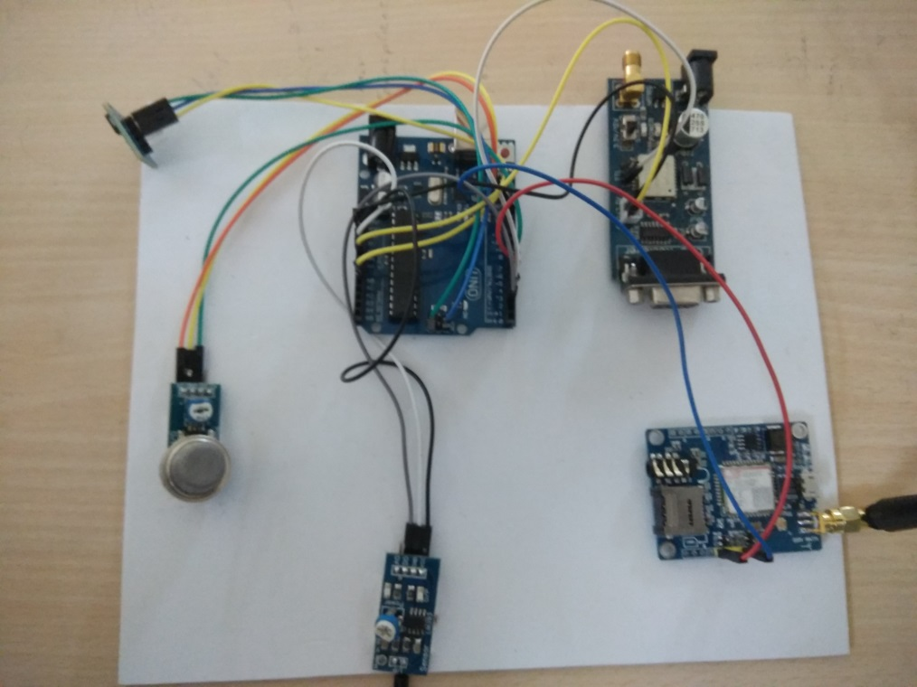

**FIG 1:** Proposed Module

**3.1. Block Diagram**

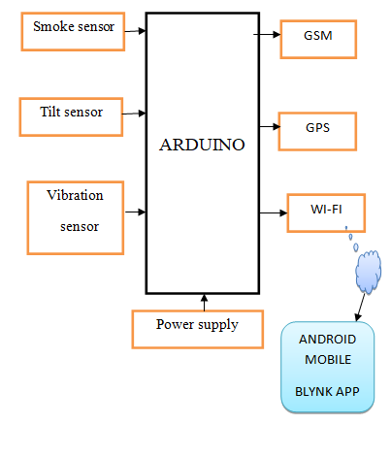

**Fig 2**: Proposed Detection System

**3.2. Algorithm**

Step 1: Start

Step 2: Vehicle starts.

Step 3: The Tilt sensor gets triggered.

Step 4: If the value is greater than 310 and lesser than 390 then end else goto step 5.

Step 5: Vehicle continues if gas sensor triggered

Step 6: If value is greater than ‘0’ then end else goto step 7.

Step 7: Vehicle continues if vibration detected.

Step 8: If vibration value is greater than ‘0’ then end else goto step 4.

Step 9: GPS will detect the location of the vehicle

Step 10: GSM will send the message to coded number.

Step 11: Stop

**3.3. Flow Chart**

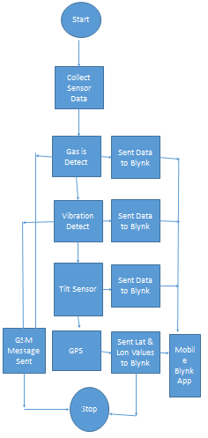

**FIG 3:** Flow Diagram

**3.4. Modules**

**Hardware:**

* Arduino UNO
* Gas sensor
* Vibration sensor
* GSM Modem
* GPS Module

**Software:**

* Arduino IDE
* Blynk App

**3.4.1. Module Description**

* Arduino UNO:

Arduino Uno is a micro-controller board to get started with the coding and electronics section with a easy understanding and with the cool features. This micro-controller has a 14 digital I/O pins. In which 6 pins can be used as pulse width modulation and 6 pins can be used as analog input pins. It has a USB cable for providing power supply through systems which can hold a maximum of 3.3V power supply. It also has a DC adapter which can hold up to 12V of power supply. It has a crystal oscillator and a reset button.

|  |  |
| --- | --- |
| Microcontroller | [ATmega328P](http://www.atmel.com/Images/Atmel-42735-8-bit-AVR-Microcontroller-ATmega328-328P_Datasheet.pdf) |
| Operating Voltage | 5V |
| Input Voltage (recommended) | 7-12V |
| Input Voltage (limit) | 6-20V |
| Digital I/O Pins | 14 (of which 6 provide PWM output) |
| PWM Digital I/O Pins | 6 |
| Analog Input Pins | 6 |
| DC Current per I/O Pin | 20 mA |
| DC Current for 3.3V Pin | 50 mA |
| Flash Memory | 32 KB (ATmega328P) of which 0.5 KB used by bootloader |
| SRAM | 2 KB (ATmega328P) |
| EEPROM | 1 KB (ATmega328P) |
| Clock Speed | 16 MHz |
| LED_BUILTIN | 13 |
| Length | 68.6 mm |
| Width | 53.4 mm |
| Weight | 25 g |
|  |  |

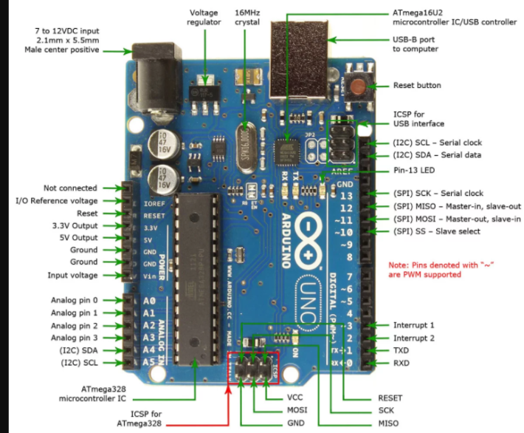

**FIG 4:** Arduino Uno

* Gas sensor:

Gas sensor which is commonly known as the alcoholic sensor is used for detecting the smoke in the place where it is kept. This sensor has a faster response time in detecting the alcohol or smoke. Few gas which this sensor can detect are Carbon dioxide, Carbon Monoxide, Sulphur Dioxide etc. It is a 4 pin configuration used for input and output.

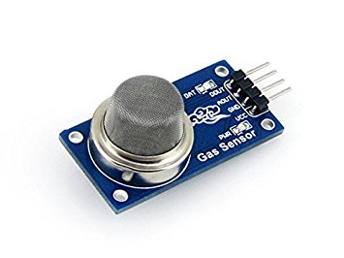

**FIG 5:** Gas Sensor

* Vibration sensor:

In this Project the vibration sensor (Piezoelectric) is used in order to detect threats. Whenever any threat is attempted this piezoelectric can send information when vibration is detected. It is a 4 pin configuration.

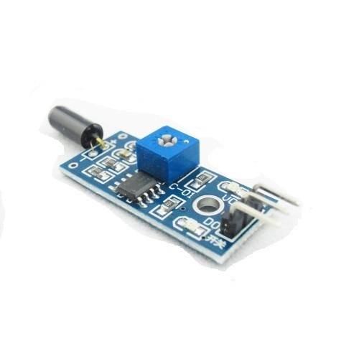

**FIG 6:** Vibration Sensor

* Tilt Sensor:

The Tilt Sensor is one of the sensor which is used for detecting accident this can be mainly used if incase a vehicle is turned upside down incase if anything goes wrong such as speed control etc. The tilt sensor is a 5 pin configuration in which we have used two pins for Inputs and a pin for output which is given to the controller.

* GSM Modem:

Most of the models use the GSM model for communication purposes so that it will be easy to share information. In this project we are using SIM800 module for the communication purpose this module works with the frequency band of 800MHz.

We make use of the GSM module in our project to send message to the concerned person in case of accident detection.

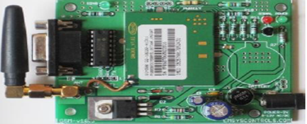

**FIG 7:** GSM Modem

* GPS Module:

The GPS used in this project is NEO6mv2. This module is used in this project for getting the latitude and longitude value through the Blynk application. This GPS module contains a antenna for receiving the latitude and longitude values from any one of the 24 satellites which revolves the earth and forms a triangular shape. The Global Positioning System is used in order to provide location of the proposed model which can share the real time tracking, which can alert the concerned person in case any emergency, it can also give a history as of where the model has moved from the starting point to the end point, you can access the it anywhere anytime needed etc.

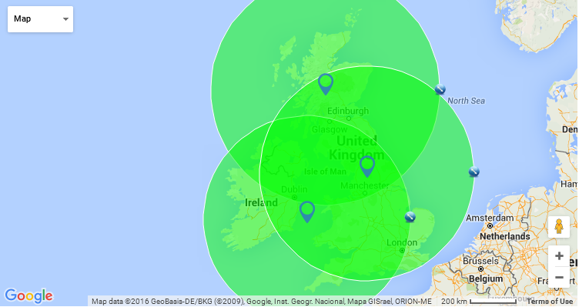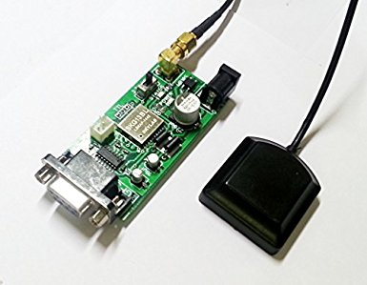

**FIG 8:** GPS Module

* Blynk App:

Blynk is a toolset for all makers, badass inventors, designers, teachers, nerds and geeks who would love to use their smartphones to control electronics like Arduino, RaspberryPi and similar ones. We’ve done all the hard work of establishing internet connection, building an app and writing hardware code.

With Blynk, you simply snap together an amazing interface from various widgets we provide, upload the example code to your hardware and enjoy seeing first results in under 5 minutes! It works perfectly for newbie makers and saves tons of time for evil geniuses.

Blynk will work with all popular boards and shields. We wanted to give you full freedom when deciding how to plug Blynk into your existing or new project. You will also enjoy the convenience of Blynk Cloud. Which is, by the way is free and open-source.

Imagine a prototyping board on your smartphone where you drag and drop buttons, sliders, displays, graphs and other functional widgets. And in a matter of minutes these widgets can control Arduino and get data from it.

Blynk is not an app that works only with a particular shield. Instead, it's been designed to support the boards and shields you are already using. And it works on iOs and Android.

**UPD:** Blynk also works over USB. This means you can tinker with the app by connecting it to your laptop or desktop while waiting for some internet shield to arrive.

**Blynk works over the Internet.**So the one and only requirement is that your hardware can talk to the Internet.

No matter what type of connection you choose - Ethernet, Wi-Fi or maybe this new ESP8266 everyone is talking about – Blynk libraries and example sketches will get you online, connect to Blynk Server and pair up with your smartphone.

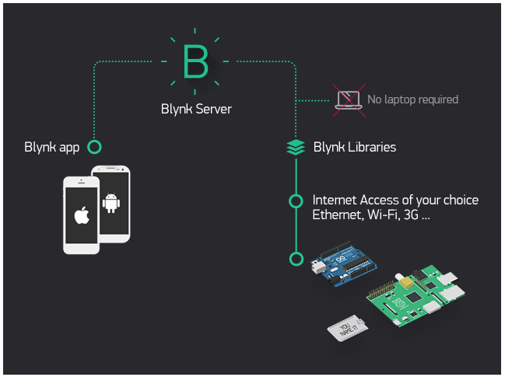

**FIG 9:** Blynk Architecture

Currently, Blynk libraries work with:

* USB
* Ethernet shield
* WiFi shield
* Arduino with Ethernet
* Arduino YÚN (testing in progress)
* ESP8266
* Raspberry Pi (Blynk will communicate with Pi’s GPIOs)
* more Arduino compatible shields and boards (this list will be updated as we test the compatibility)

**CREATING A PROJECT IN BLYNK APP**

* After downloading the app, create an account and log in. Welcome to Blynk!

[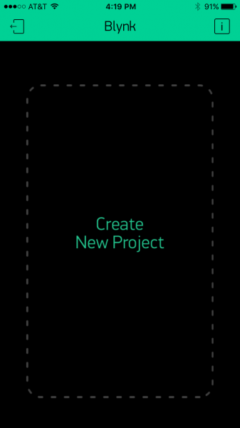](https://cdn.sparkfun.com/assets/learn_tutorials/4/4/5/blynk-blank.PNG)

* You’ll also need to install the **Blynk Arduino Library**, which helps generate the firmware running on your ESP8266. Download the latest release from Blynk’s GitHub repo, and follow along with the directions there to install the required libraries.

### Create a Blynk Project

* Next, click the “Create New Project” in the app to create a new Blynk app. Give it any name you please, just make sure the “Hardware Model” is set to **ESP8266**.

[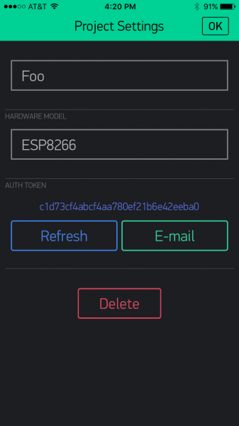](https://cdn.sparkfun.com/assets/learn_tutorials/4/4/5/Blynk-new.PNG)

* The **Auth Token** is very important – you’ll need to stick it into your ESP8266’s firmware. For now, copy it down or use the “E-mail” button to send it to yourself.

### Add Widgets to the Project

* Then you’ll be presented with a blank new project. To open the widget box, click in the project window to open.

[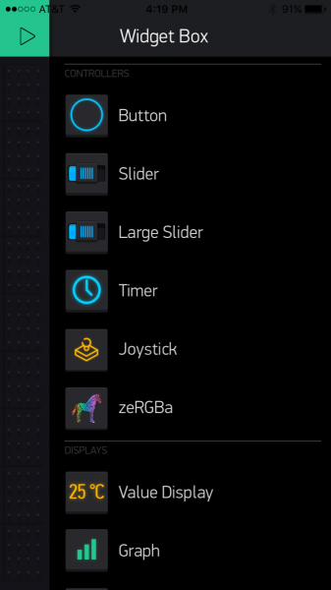](https://cdn.sparkfun.com/assets/learn_tutorials/4/4/5/Blynk-widgetBox.PNG)

* Add a **Button**, then click on it to change its settings. Buttons can toggle outputs on the ESP8266. Set the button’s output to **gp5**, which is tied to an LED on the Thing Dev Board. You may also want to change the action to “Switch.”

[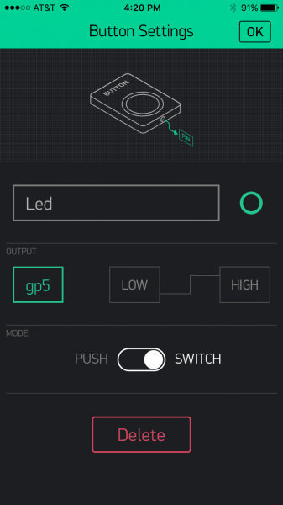](https://cdn.sparkfun.com/assets/learn_tutorials/4/4/5/Blynk-Button.PNG)

### Upload the Blynk Firmware

* Now that your Blynk project is set up, open Arduino and navigate to the **ESP8266_Standalone** example in the **File** > **Examples** > **Blynk** > **BoardsAndShields** menu.

[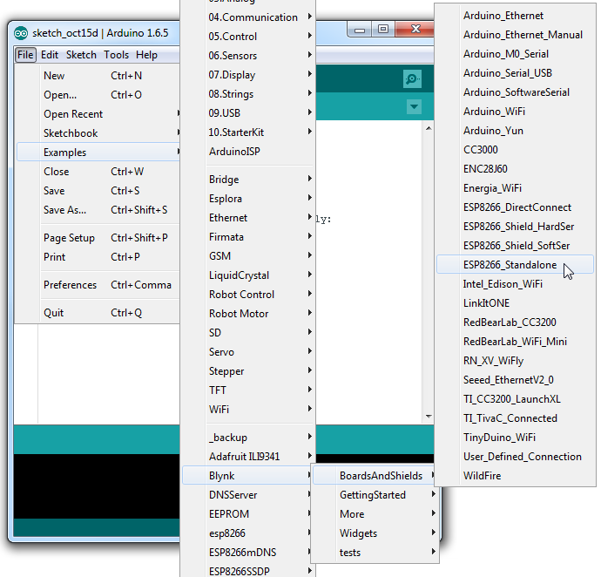](https://cdn.sparkfun.com/assets/learn_tutorials/4/4/5/Blynk-example.png)

* Before uploading, make sure to paste your **authoriazation token** into the auth[] variable. Also make sure to **load your WiFi network settings into the Blynk.begin(auth, “ssid”, “pass”)** function.
* Then upload!

### Run the Project

* After the app has uploaded, open the serial monitor, setting the baud rate to 9600. Wait for the “Ready (ping: xms).” Message.

[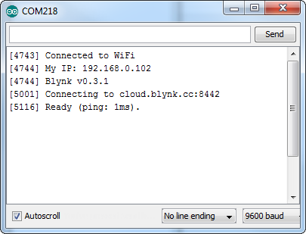](https://cdn.sparkfun.com/assets/learn_tutorials/4/4/5/Blynk-Serial.png)

* Then click the “Run” button in the top right corner of the Blynk app. Press the button and watch the LED!

[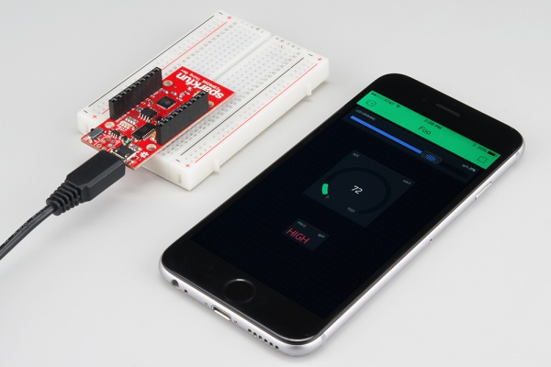](https://cdn.sparkfun.com/assets/learn_tutorials/4/4/5/esp8266-blynk.jpg)

* Then add more widgets to the project. They should immediately work on the ESP8266 without uploading any new firmware.

**4. RESULT**

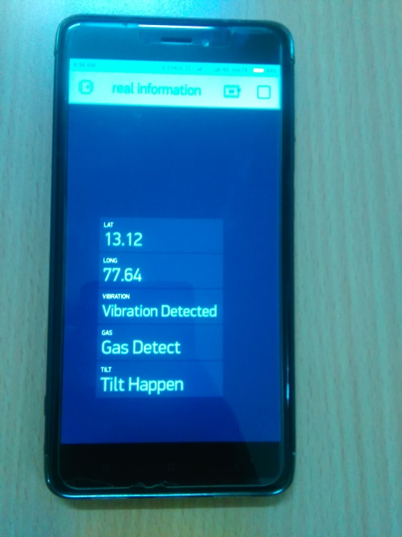

**Fig 10**: Results

* The Blynk application is used to show the information when an accident is detected or any changes happens in the sensors. The application is used to show the value of the sensors such as Latitude, Longitude, Vibration, Gas and Tilt.
* The first value 13.12 is the value of Latitude of the location where accident occurred.
* The second value 77.64 is the value of Longitude of the location where accident occurred.
* The next is the value of vibration when there is an occurrence of vibration
* The gas sensor is detected when there is any changes in the sensor made.
* The similar way tilt value is shown when there is any occurrence in sensor value.

**5. CONCLUSION**

This proposed model is for the detection of the vehicle accident. The proposed model can be a support for building up a smart transportation system if we utilize this model in a proper way. In this proposed model we have placed various sensors which detect the accident such as Gas sensor, Tilt sensor, and a vibration sensor. If the range of the sensor increases to the maximum value then the information is sent to the controller board. Also, the information is stored in the Blynk server. In turn the information is sent to the Blynk application and through a SMS for the concerned person’s number with the exact coordinating values of the latitude and longitude.

**6. FUTURE SCOPE AND ENHANCEMENT**

This system can be enhanced by adding some features like Alcohol detection sensor, impact sensor and riders fatigue detection system to provide better safety and security to the riders. This system can be interfaced with vehicle air bag system that prevents occupant from striking inertial objects such as steering wheel or window. This can also be developed by interconnecting camera to controller module that takes photograph of accident spots and makes the tracking easier.

We can apply shortest path Algorithm based on distance to find nearby Hospitals and we can add some more modules which will also let the system know about Traffic details and then find out which traffic route will take less time to reach the accident spot. Adding some more modules which measures the injury level or some additional information like blood group, heart beats, current Glucose level which may be sent to Hospital in advance before the victim reaches the Hospital hence improvise the performace of the propose system.

**7. REFERENCES**

[1] Sachin M S, Prasanna P, “**Automatic vehicle accident detection and traffic control system**”, International Journal on Recent and Innovation Trends in Computing and Communication, Vol. 3 Issue 6, 2015.

[2] D. Kumar, S. Gupta et. al., “**Accident Detection and Reporting System Using GPS and GSM Module**”, Journal of Emerging Technologies and Innovative Research, Volume 2, Issue 5, 2015.

[3] Sri Krishna C Varma, Poornesh et. al. “**Auto matic Vehicle Accident Detection and Messaging System Using GPS and GSM Modem**”, International Journal of Scientific & Engineering Research, Volume 4, Issue 8, 2013.

[4] Pratiksha R., Shetgaonkar et. al., “**Proposed Model for the Smart Accident Detection System for Smart Vehicles using Arduino board, Smart Sensors, GPS and GSM**” International Journal of Emerging Trends & Technology in Computer Science vol. 4, issue 4, 2015.

[5] Wang Wei, Fan Hanbo― “**Traffic Accident Automatic Detection And Remote Alarm Device**”, IEEE , 2011.

[6] C.Prabha, R.Sunitha, R.Anitha., “**Automatic Vehicle Accident Detection AND Messaging System Using GSM AND GPS Modem**” IJAREEIE 7, July 2016

[7] Vikram Singh Kushwaha, Deepa Yadav “**Car Accident Detection System Using GPS, GSM AND Bluetooth**” , IJERGS May-June 2015.

[8] Aboli RavindraWakure, ApurvaRajendraPatkar “**Vehicle Accident Detection And Reporting System Using GPS AND GSM**.” IJERGS April 2017.

**systems**”.

[9] “**Automatic accident notification system using gsm and gps modems with 3g technology for video video monitoring**” International Journal of Emerging Trends in Electrical and Electronics (IJETEE) Vol. 1, Issue. 2, March-2013.

[10] “**Vehicle accident alert and locator**” International Journal of Electrical & Computer Sciences IJECS-IJENS

[11] The 8051 Microcontroller and Embedded Systems” by Muhammad Ali Mazidi and Janice Gillispie Mazidi, Pearson Education.

[12] “**8051 Microcontroller Architecture, programming and application**” by KENNETH JAYALA.

[13] GSM modem Wireless Communication by THEODORE RAPPAPORT

[14] “**Automatic traffic accident detection and alarm system**” International Journal of Technological Exploration and Learning (IJTEL) Volume 1 Issue 1 (August 2012).

[15] Y. Zhao – “**Mobile phone location determination and its impact on intelligent transportation**